NAMA : LANI SRI AGUSTIN

KELAS : 11 RPL

FORM LOGIN  
JDK & NETBEANS

SCREENSHOTS KODE PROGRAM

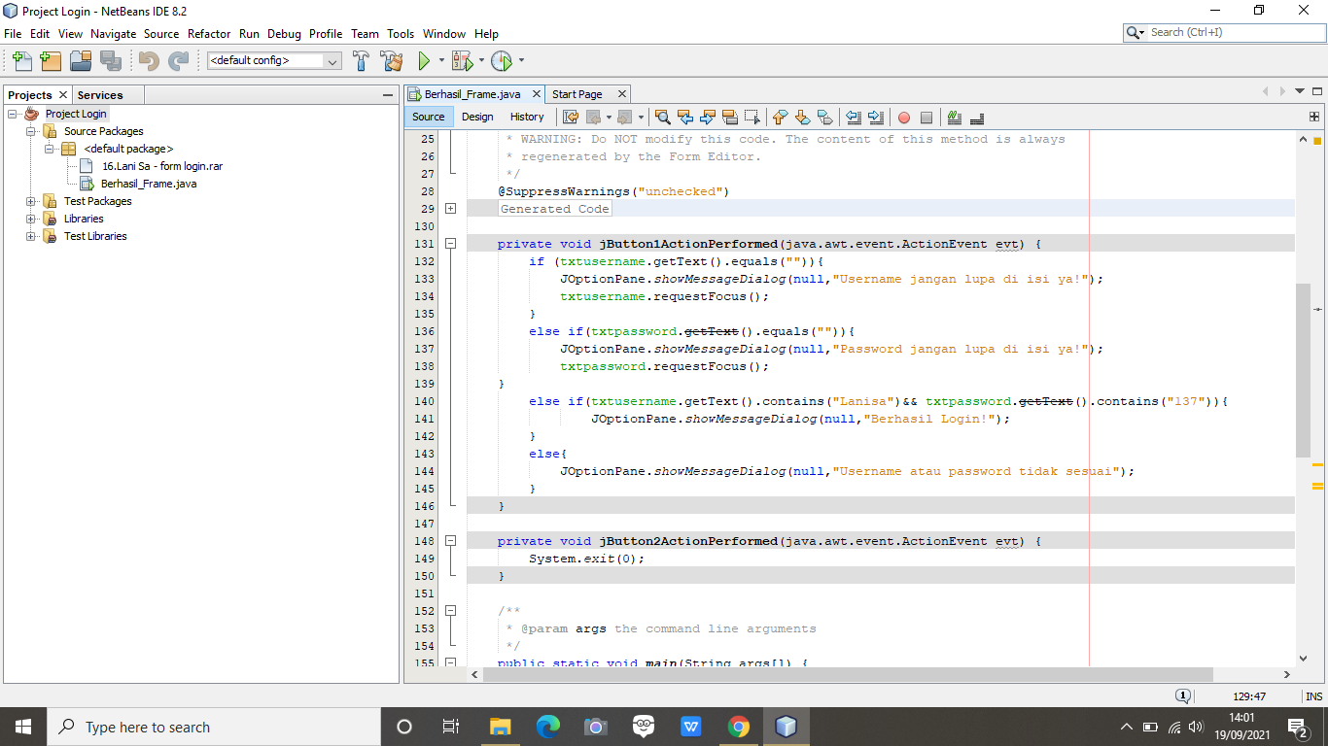

SCREENSHOTS OUTPUT

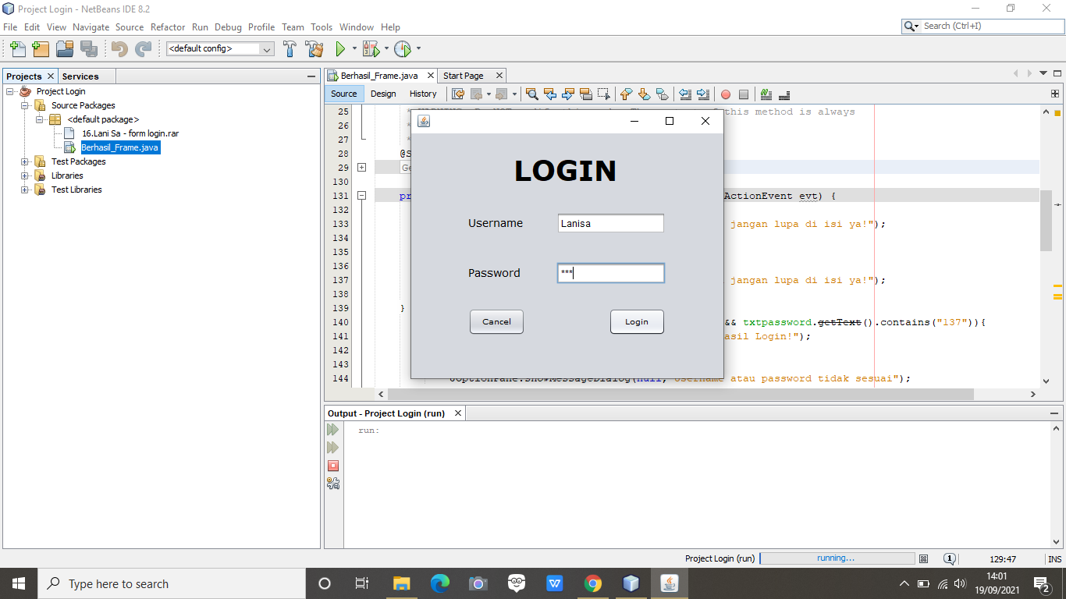

SCREENSHOTS OUTPUT JIKA USERNAME / PASSWORD SALAH

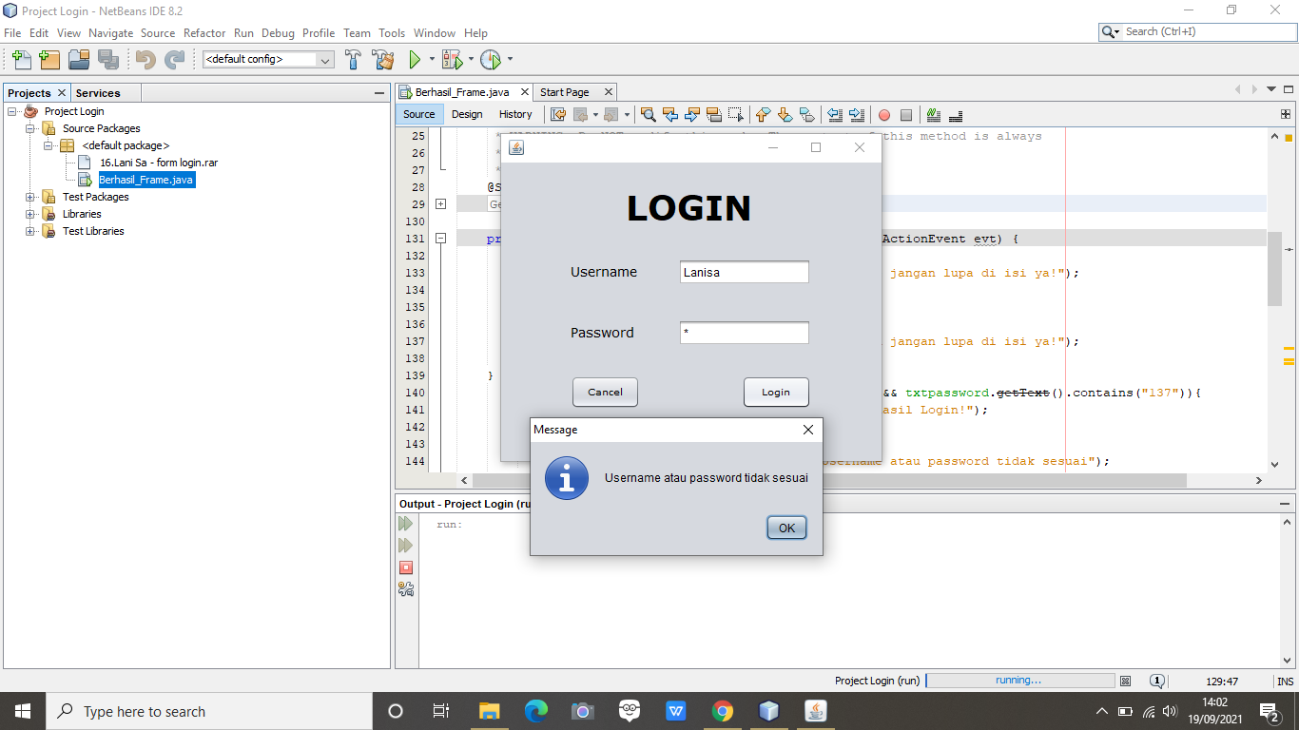

SCREENSHOTS OUTPUT BUTTON LOGIN (BERHASIL LOIN)

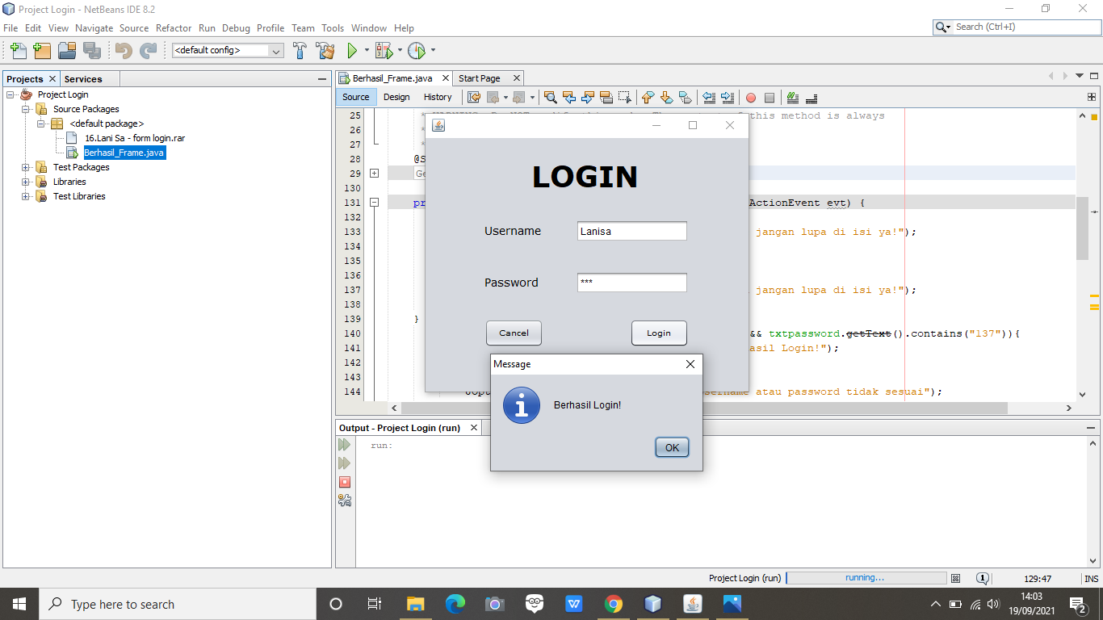

SCREENSHOTS OUTPUT USERNAME / PASSWORD LUPA ISI

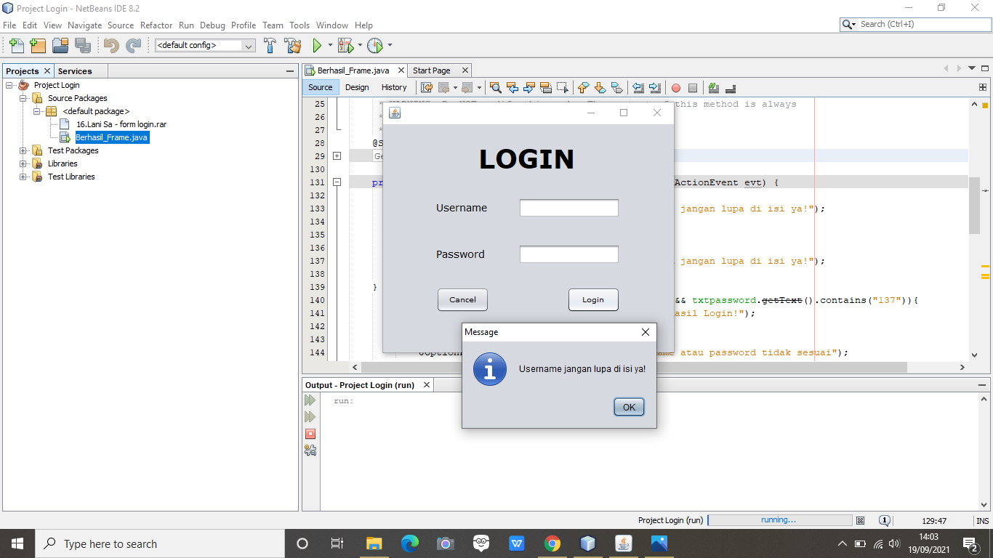

SCREENSHOTS OUTPUT BUTTON CANCEL  
